

DEPARTMENT OF COMPUTER SCIENCE
WITH ARTIFICIAL INTELLIGENCE

IBM PROJECT
ONLINE SHAPPING DATA ANALYSIS FOR CUSTOMER PREFERENCE IDENTIFICATION
Submitted by
ANNAL NADHISHA.M(222511537)
ILAVARASI.G(222511541)
HAJIRA BANU(222511554)

BACHELOR OF SCIENCE IN COMPUTER
SCIENCE WITH ARTIFICIAL INTELLIGENCE

Under the guidance of
Mr.KAVIN CHAKARAVARTHI V M- Corporate Trainer

2025-2026

DECLARATION

We,ANNAL NADHISHA M, ILAVARASI G and HAJIRA BANU hereby declare that this project report on “Online Shoppind Data Analysis For Customer Preference Identification” submitted to the University of Madras in partial fulfillment of the requirement for the award of the Degree Bachelor of Computer Science with Artificial Intelligence under the guidance of MRS CAROLIN JOSHIPA.,OF DEPARTMENT and Mr.Kavin Chakaravarthi V M has not been submitted earlier to any other university or institute for the award of any degree.

ANNAL NADHISHA.M
ILAVARASI.G
HAJIRA BANU

Place: PADUR
Date: 03/02/2026

BONAFIDE CERTIFICATE
This is to certify that the project titled “Online Shopping Data Analysis For Customer Preference Identification” is the bonafide work done by,Annal Nadhisha.M, Ilavarasi.G and Hajira Banu hereby and First-year student of Jeppiaar College of Arts and Science, Padur, Chennai in partial fulfillment of the requirement for the award of the Degree of Bachelor of Computer Science with Artificial Intelligence 2025-2026.

PROJECT GUIDE: HEAD OF THE DEPARTMENT:

Mr.KAVIN CHAKARAVARTHI V M MRS.CAROLIN JOSHIPA
Date: 03/02/2026

S. No | INDEX | Page No
 | Introduction
 | Abstraction
 | Overview of Online Shopping Data Analysis
 | Problem Statement
 | Objectives of the Study

Methodology

1. Data Collection

2. Data Preprocessing

3. Exploratory Data Analysis (EDA)

4. Customer Preference Analysis

5. Interpretation of Results

 | Data Visualization
 | Conclusion
 | References

Online Shopping Data Analysis for Customer Preference Identification

1.Introduction
The rapid growth of e-commerce platforms has significantly transformed the way consumers purchase goods and services. Online shopping generates massive volumes of data related to customer behavior, preferences, browsing patterns, purchase history, and feedback. This data, when analyzed effectively, provides valuable insights into customer preferences and decision-making processes. Understanding customer preferences is crucial for online retailers to improve customer satisfaction, personalize recommendations, optimize inventory, and increase sales performance.
Data analysis plays a vital role in identifying patterns and trends hidden within large datasets. By applying analytical techniques to online shopping data, businesses can better understand what customers want, how they behave, and why they make certain purchasing decisions. This project focuses on analyzing online shopping data to identify customer preferences and support data-driven business strategies.

2.Abstract

Online shopping platforms collect extensive data from customer interactions, including demographic details, purchase behavior, product ratings, and browsing history. The primary aim of this study is to analyze online shopping data to identify customer preferences using data analysis techniques. The project involves data collection, preprocessing, exploratory data analysis, and visualization to uncover meaningful patterns and insights. By analyzing factors such as product categories, price sensitivity, purchase frequency, and customer ratings, the study helps businesses understand customer needs more effectively. The results of this analysis can be used to improve personalized marketing, recommendation systems, and overall customer experience in e-commerce platforms.

3.Overview of Online Shopping Data Analysis
Online shopping data analysis involves examining customer-related data to extract useful information that supports business decision-making. The data may include customer demographics, transaction records, product details, payment methods, and customer feedback. With the growth of digital commerce, analyzing this data has become essential for gaining a competitive advantage.
Customer preference identification focuses on understanding customer interests, likes, dislikes, and purchasing patterns. Businesses use this information to recommend relevant products, design targeted marketing campaigns, and improve service quality. Modern data analysis techniques such as descriptive statistics, clustering, classification, and visualization help transform raw data into actionable insights.
4.Problem Statement
Despite the availability of large volumes of online shopping data, many organizations struggle to effectively analyze and utilize this data to understand customer preferences. Raw data is often unstructured, incomplete, or inconsistent, making analysis challenging. Without proper analysis, businesses may fail to recognize customer needs, leading to poor personalization, low customer retention, and reduced profitability.
The problem addressed in this project is the lack of systematic analysis of online shopping data to accurately identify customer preferences. There is a need for an efficient analytical approach that can extract meaningful insights from complex datasets and support informed business decisions.

5.Objectives of the Study
The main objectives of this project are as follows:
- To analyze online shopping data to understand customer behavior and preferences
- To identify patterns and trends in customer purchasing behavior
- To examine the relationship between customer preferences and product features
- To visualize customer data for better interpretation and decision-making
- To support personalized marketing and recommendation strategies using data insights

6.Methodology
The methodology used in this project follows a structured data analysis process consisting of several key stages:

1. Data Collection
The data is collected from online shopping platforms or publicly available datasets. The dataset typically includes customer details, product categories, purchase history, ratings, and transaction information.

2. Data Preprocessing
Data preprocessing is performed to clean and prepare the data for analysis. This step includes handling missing values, removing duplicates, correcting inconsistencies, and transforming data into a suitable format.

3. Exploratory Data Analysis (EDA)
Exploratory Data Analysis is conducted to understand the basic structure of the data. Statistical techniques are used to analyze distributions, averages, and correlations between variables. This step helps in identifying initial patterns and trends.

4. Customer Preference Analysis
Customer preferences are analyzed based on factors such as frequently purchased products, preferred price ranges, popular product categories, and customer ratings. Segmentation techniques may be used to group customers with similar preferences.

5. Interpretation of Results
The analyzed data is interpreted to draw meaningful conclusions. Insights are derived to understand customer behavior and support business strategies.

7.Data Visualization
Data visualization plays a crucial role in presenting analytical results in an easy-to-understand format. Visual representations help identify trends, patterns, and relationships within the data more effectively than numerical analysis alone.
Common visualization techniques used in this project include:
- Bar charts to represent product category preferences
- Pie charts to show customer distribution across categories
- Line graphs to analyze purchasing trends over time
- Histograms to understand price sensitivity and spending behavior
Visualization enhances clarity and helps stakeholders make informed decisions quickly.

8.Conclusion
Online shopping data analysis is an effective approach for identifying customer preferences and improving e-commerce business performance. By analyzing customer behavior, purchase patterns, and product preferences, businesses can gain valuable insights that support personalized marketing, better product recommendations, and improved customer satisfaction.
This study demonstrates that systematic data analysis combined with effective visualization can transform raw online shopping data into meaningful knowledge. Understanding customer preferences enables businesses to adapt to changing market demands and maintain a competitive edge in the digital marketplace. Future work may include the application of advanced machine learning techniques to further enhance customer preference prediction.

9.References
- Han, J., Kamber, M., & Pei, J. (2012). Data Mining: Concepts and Techniques. Morgan Kaufmann Publishers.
- Provost, F., & Fawcett, T. (2013). Data Science for Business: What You Need to Know about Data Mining and Data-Analytic Thinking. O’Reilly Media.
- Laudon, K. C., & Traver, C. G. (2020). E-Commerce: Business, Technology, Society. Pearson Education.
- Aggarwal, C. C. (2015). Data Mining: The Textbook. Springer International Publishing.
- Turban, E., Volonino, L., Wood, G., & Sipior, J. (2018). Information Technology for Management: Digital Strategies for Insight, Action, and Sustainable Performance. Wiley.

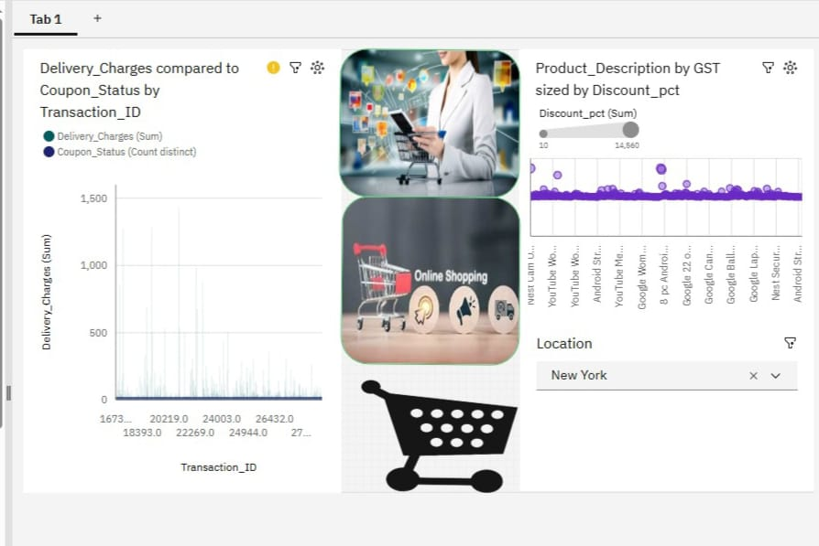

https:/ /github.com/ilavarasi11/online-shopping/upload

